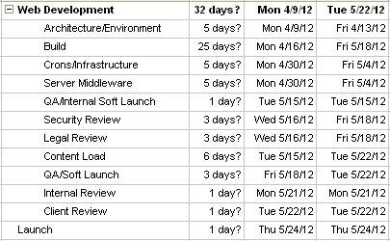

Architecture/Environment

* Includes the setup of any initial environments after receiving approval of URL’s
* Can parallel with UX and Creative

Build

* Timeframe varies depending on the size of the project

Crons/Infrastructure

* Acquiring server and databases

QA/Internal Soft Launch

* Only for internal team, to test in dev environment
* This time can vary depending on the size of the site

Security/legal review

* This can usually happen at the same time. Best to have both teams aware of this coming with an email preferably 2-3 weeks prior with an SOW or PRD attached

Content Load

* As soon as the production environment is set up, content load can begin. Depending on how content is being loaded, how much and by whom, use discretion as to when this begins.

QA/Soft Launch

* Amount of time can vary.

1. Kickoff
2. Final prd
3. Wires signoff
4. Html
5. Qa
6. staging

DNS

* Contact me to register a domain name and advise how the business plans to use the domain name (e.g., redirect to Sears.com or Kmart.com, or point to a new web site, etc.).  If it is a new web site, associates should describe any goods and services that will be offered on the site.
* I will check domain name availability.  If available, I will check to see whether a trademark search first needs to be conducted to clear the domain name for use and registration.
* If no trademark search is needed, I will send a message to our corporate registrar CSC Corporate Domains requesting that they register the domain name.
* If a trademark search is needed, I will have our trademark paralegal Laura Wells have the term in the domain name searched.
* If the results of the trademark search show that the term in the domain name is clear for use and registration, I will send a message to CSC requesting that they register the domain name.
* Trademark search turnaround can take a few days.  If we determine there is a need for a trademark search, the domain name cannot be registered until I’m advised it is clear for use
* Domain name registration turnaround is typically within the hour, and CSC sends me an e-mail letting me know when the domain name is registered.
* Depending what servers apply, the business will need to work directly with the technical contact to get the domain name set up on the servers.  If it is on SHC’s servers, the business needs to work with Sears’ DNS Team.

Dev.  
   
1.      Kickoff-1 day  
  
2.      DNS purchase request from Linda/purchased- 1-5 days  
  
3.      Open jira for Vanity URL-informing Dev ops  
  
4.      Estimate—1day  
  
5.      Code  
  
•        Front end ~ 3 month?  
  
•        CMS ~3 months?  
  
•        API ~  3 months ?  
  
6a.      Basic QA- 1 week  
  
6b. Security-1week, open jira

7. Showcase- 1-3 days prior to launch  
  
8.      Get final DNS Jira to point VIP to our Server